**DAILY ONLINE ACTIVITIES SUMMARY**

|  |  |  |  |  |  |  |  |  |
| --- | --- | --- | --- | --- | --- | --- | --- | --- |
| **Date:** | 26/05/2020 | | | | | **Name:** | D Richard Franklin | |
| **Sem & Sec** | Fourth SEM section A | | | | | **USN:** | 4AL18CS020 | |
| **Online Test Summary** | | | | | | | | |
| **Subject** | | Design and analysis of algorithm | | | | | | |
| **Max. Marks** | | 30 | | **Score** | | | 26 | |
| **Certification Course Summary** | | | | | | | | |
| **Course** | [Certified Kubernetes Administrator (CKA) with Practice Tests](https://www.udemy.com/course/certified-kubernetes-administrator-with-practice-tests/) | | | | | | | |
| **Certificate Provider** | | | Udemy | | **Duration** | | | 2 Hours |
| **Coding Challenges** | | | | | | | | |
| **Problem Statement:** 1. Number of permutations of a given string  2. Number of subarrays of the given type | | | | | | | | |
| **Status:** Completed | | | | | | | | |
| **Uploaded the report in Github** | | | | | YES | | | |
| **If yes Repository name** | | | | | <https://github.com/richard3658/lockdown-coding> | | | |
| **Uploaded the report in slack** | | | | | YES | | | |

**Online Test Details:**

The online test was from module 2 which was about divide and conquer algorithms and decrease and conquer algorithms. There were 30 questions and the duration was 45 minutes. The questions were optimal and were easy. The score that I got in the test is 26/30.

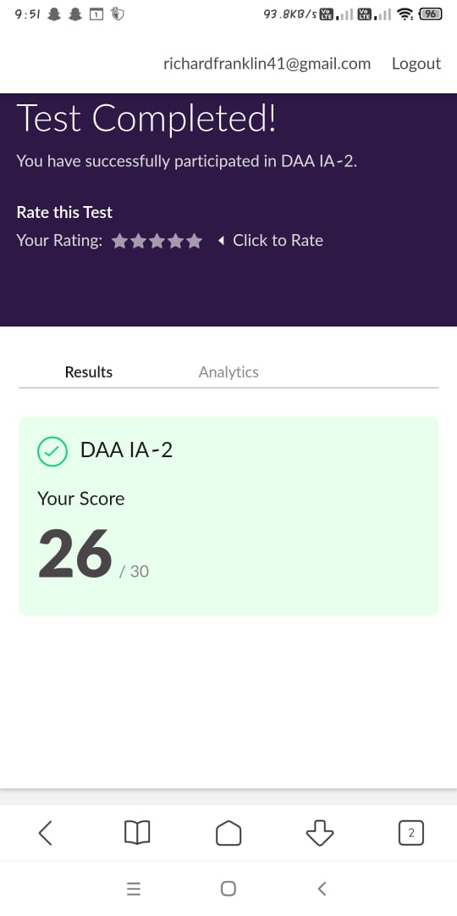

**Certification Course Details:**

**Name of the course**: [Certified Kubernetes Administrator (CKA) with Practice Tests](https://www.udemy.com/course/certified-kubernetes-administrator-with-practice-tests/)

**Certificate Provider**: Udemy

This course has 17 sections and the total duration is 15 hours.

In the Eighth day I went through the section of this new course that gave the introduction regarding kubernetes and its core concepts. And how it can be used for the future world of cloud computing.

**Snapshot:**

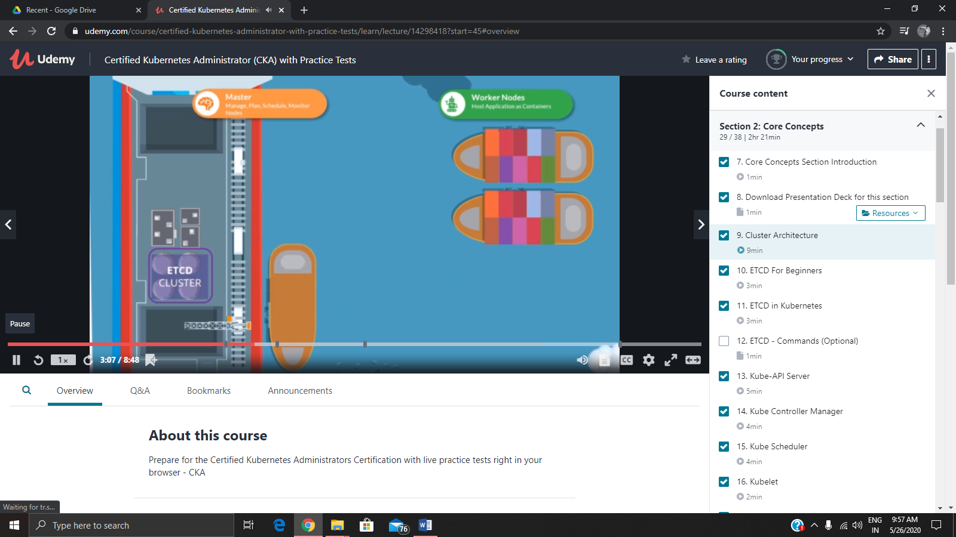

**Online Coding Details:**

Problem 1: (using C language) [Write a program in C to print all permutations of a given string using pointers.](https://github.com/orgs/alvas-education-foundation/teams/2nd-year/discussions/81)

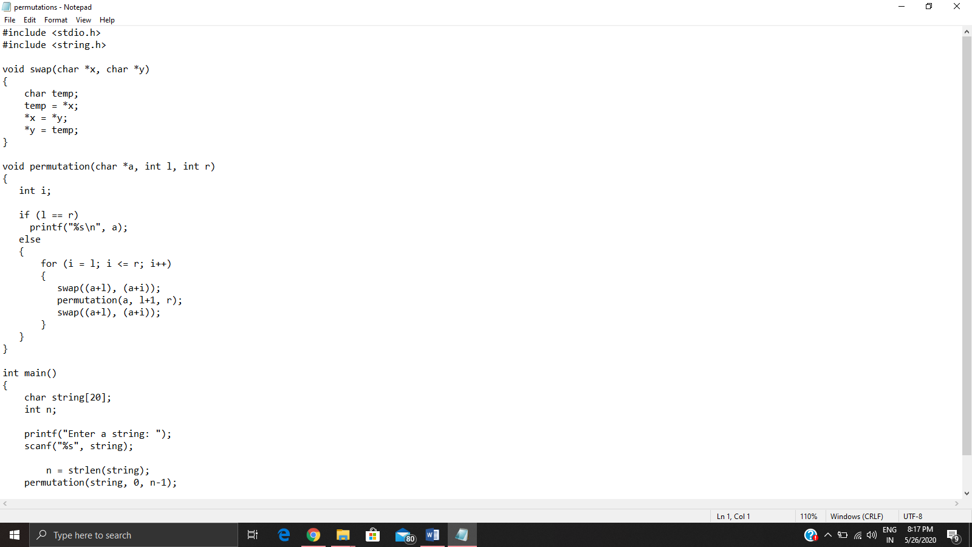

Problem 2: (Using JAVA) [Given an array A of size N where the array elements contain values from 1 to N with duplicates, the task is to find total number of subarrays which start and end with the same element.](https://github.com/orgs/alvas-education-foundation/teams/2nd-year/discussions/80)

